Level Three Geography

91429 Demonstrate understanding of a given environment(s) through selection and application of geographic concepts and skills

Resource Booklet
Resource A: Establishing the Chatham Islands
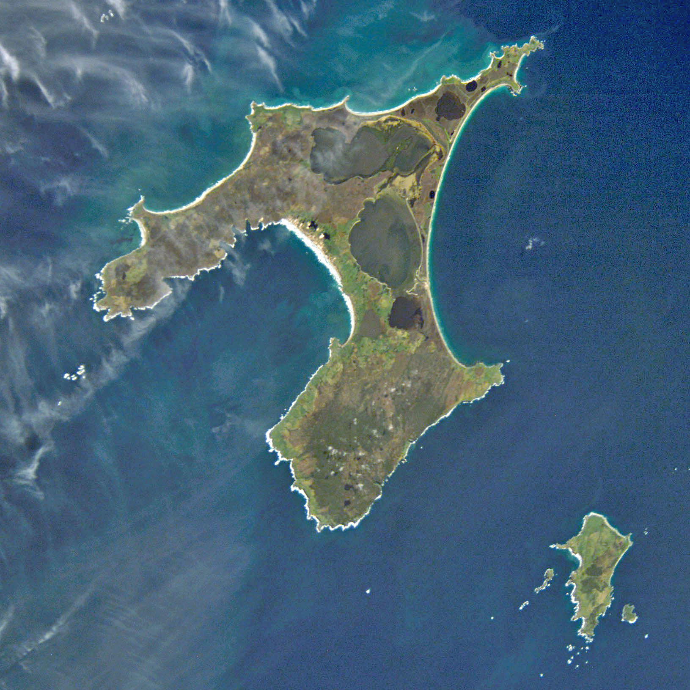
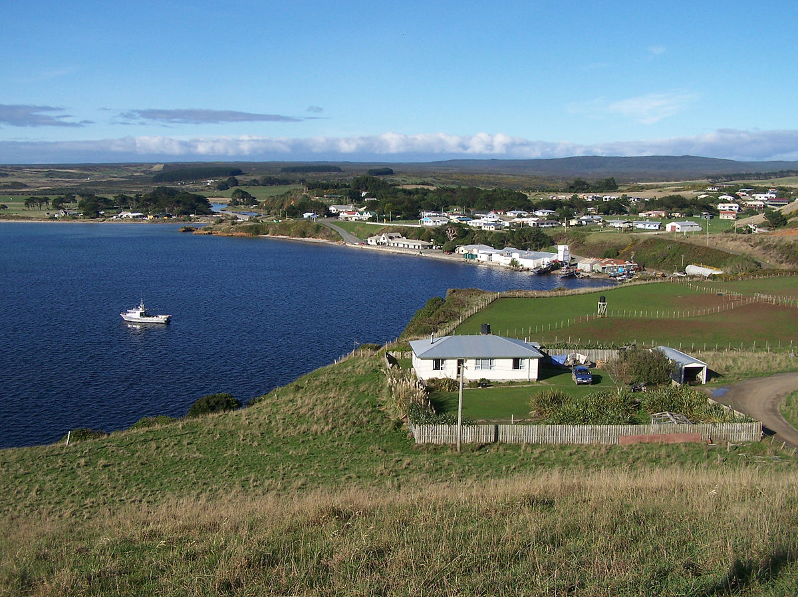
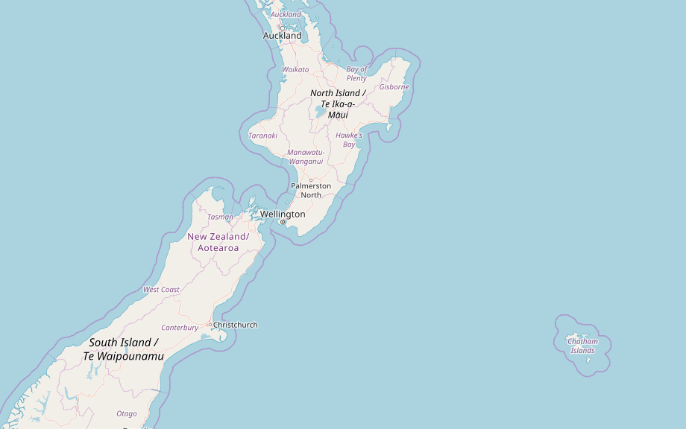

The Chatham Islands form an archipelago in the Pacific Ocean about 800 kilometres (500 mi) east of the South Island of New Zealand. It consists of about ten islands within a 40-kilometre (25 mi) radius, the largest of which are Chatham Island and Pitt Island. Some of these islands, once cleared for farming, are now preserved as nature reserves to conserve some of the unique flora and fauna. The resident population is 600 (as of 2013). The islands' economy is largely dependent on conservation, tourism, farming and fishing.

The archipelago is called Rēkohu ("Misty Sun") in the indigenous Moriori language, and Wharekauri in Māori. The Moriori are the indigenous people of the Chatham Islands, and members of the Māori Ngāti Mutunga tribe have also settled on the island. It has officially been part of New Zealand since 1842 and includes the country's easternmost point, the Forty-Fours.

Local administration of the Chatham Islands is provided by the Chatham Islands Council, whose powers are similar to other unitary authorities. It is not part of any region.

Resource B: Topographic map
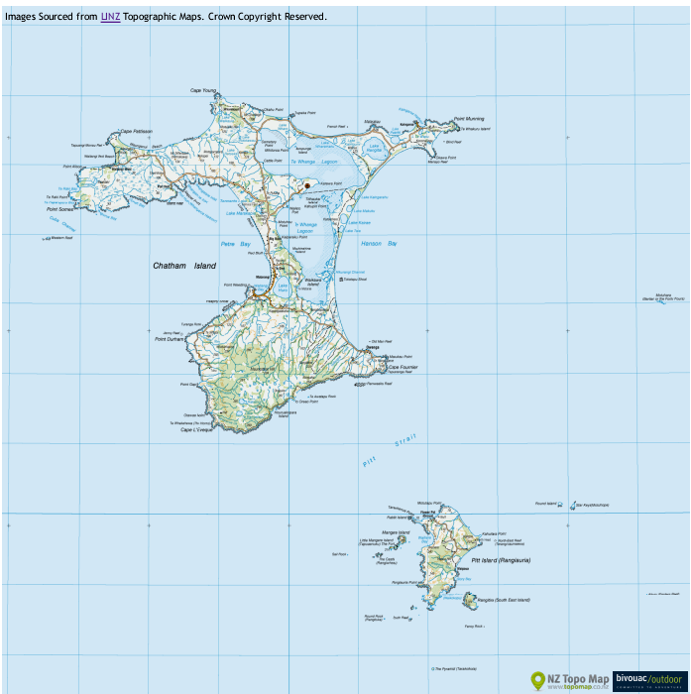
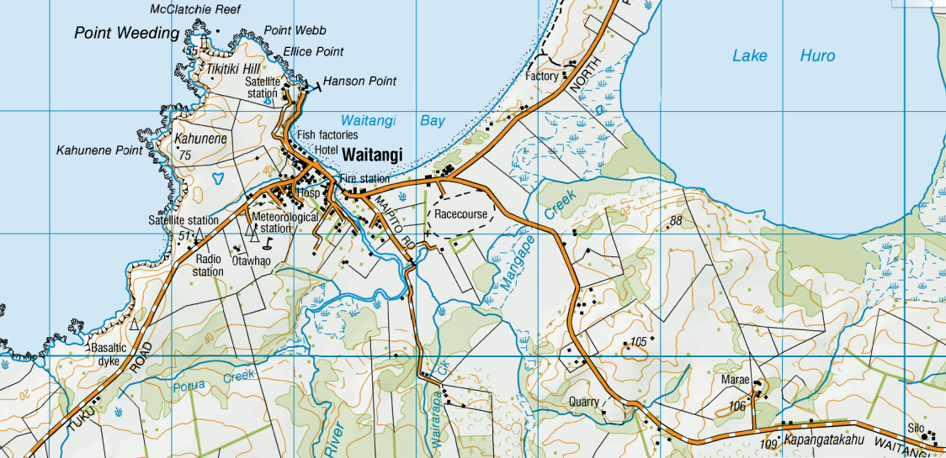
Resource C: Chatham Islands
The Chatham Islands are not subantarctic. They are to the east of New Zealand – 862 kilometres from Christchurch but only 772 kilometres from Napier. They are 45 minutes ahead of New Zealand time.
The island group includes many small islands, but only the two main ones are inhabited: Chatham Island, also called Rēkohu or Wharekauri, and Pitt Island, also known as Rangihaute or Rangiāuria.
Geology
The Chatham Islands are connected to mainland New Zealand by the underwater Chatham Rise. The islands’ rock is both volcanic and sedimentary, and the soil of the main island is mostly peat.
Plants
The Chatham Islands have no big trees. The vegetation has changed extensively since the arrival of European settlers.
Birds and animals
The sea around the Chatham Islands is rich in fish. There are huge flocks of seabirds on the islands. Native birds on the islands include some rare and endangered species – the tāiko (magenta petrel), the black robin and the huge parea (Chatham Island pigeon).
Settlers
The people who became the Moriori arrived on the islands from Eastern Polynesia and New Zealand around 1400 AD. They had no contact with other people for about 400 years, and developed their own distinct culture. They were hunter-gatherers with strong religious beliefs, and outlawed war and killing.
In 1791 an English ship, the Chatham, was blown off course and landed on the main island. Later European sealers, settlers and whalers arrived.
In 1835 two Māori groups, Ngāti Tama and Ngāti Mutunga, invaded the Chatham Islands. They had left northern Taranaki due to warfare, and were seeking somewhere else to live. Moriori decided to greet them peacefully, but the Māori killed more than 200 Moriori and enslaved the rest.
Māori grew vegetables and traded with the Europeans. By 1870 most of the Māori had returned to Taranaki. Some of the whalers stayed on the islands and there was intermarriage between the different ethnic groups.

Development
Sheep farming has been carried out on the island since 1842, but it was not profitable in the 21st century. A wharf was built at Waitangi in the 1930s, and roads were built in the 1940s. A flying-boat service operated between 1940 and 1966, when it was replaced by conventional aircraft.
In the early 1960s the government considered encouraging people to move from the islands to the New Zealand mainland. In the 1960s there was a crayfish boom which lasted until the 1970s.
The Chatham Islands Enterprise Trust was set up in 1991, and it manages the islands’ wharf, airfield and other assets.
In the 2010s fishing continues to be a major economic activity, along with tourism.
Chatham Islands places
Waitangi is the main settlement of the Chatham Islands, and has a wharf, hospital, post office, shops, police and accommodation. Nearby Te One has the main primary school, an Anglican church and the DOC headquarters.
Fossils have been found along the north-west peninsula. Kāingaroa is the most north-eastern settlement on Chatham Island, and was where Ngāti Tama were based between 1835 and 1868.
Te Whanga Lagoon is more than twice the size of Wellington Harbour. It was a bay, but the entrance has been enclosed by sand dunes.
Manukau Point, in the south-east, is an important centre for Moriori. Ōwenga was probably the first place settled on the main island. Launches go from there to Pitt Island (Rangihaute or Rangiāuria).
There are several other small islands, all of which are uninhabited nature reserves.
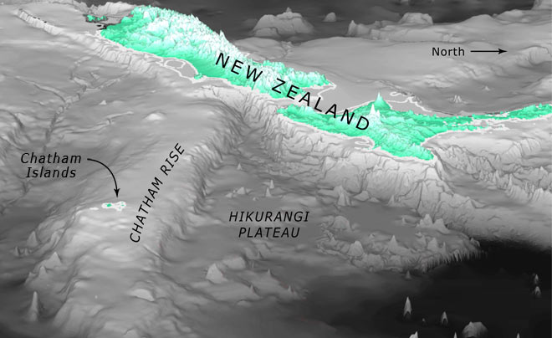
Resource D: Statistics

Number of people counted
- 600 people usually live in Chatham Islands. This is a decrease of 9 people, or 1.5 percent, since the 2006 Census.
- Chatham Islands has 100.0 percent of Chatham Islands Territory's population.
Population of Chatham Islands and Chatham Islands Territory
2013 Census
Sex | Chatham Islands | Chatham Islands Territory
Male | 315 | 315
Female | 285 | 285
Total people | 600 | 600
Source: Statistics New Zealand

Note: All figures are for the census usually resident population count.

Number of dwellings counted
- There are 264 occupied dwellings and 69 unoccupied dwellings in Chatham Islands.
- For Chatham Islands Territory as a whole, there are 264 occupied dwellings and 69 unoccupied dwellings.
- There are 3 dwellings under construction in Chatham Islands, and 3 under construction in Chatham Islands Territory.
Note: This time series is irregular. Because the 2011 Census was cancelled after the Canterbury earthquake on 22 February 2011, the gap between this census and the last one is seven years. The change in the data between 2006 and 2013 may be greater than in the usual five-year gap between censuses. Be careful when comparing trends.
This data has been randomly rounded to protect confidentiality. Individual figures may not add up to totals, and values for the same data may vary in different text, tables and graphs. For areas with small populations, the data may not look as expected because of this rounding.

Resource E: Volunteering on the Chatham Islands
Every July, excitement builds when the annual list of volunteering opportunities for the Chatham Islands is posted on the DOC website. Almost a dozen different trips to the iconic islands of Mangere and Rangatira are punctuated with names of species so rare, some will have never heard of them.
For some the dream begins when first reading about the black robin as a child. It's then rekindled every time someone casually mentions they have visited these mysterious islands and were lucky enough to be involved in the conservation work going on there.
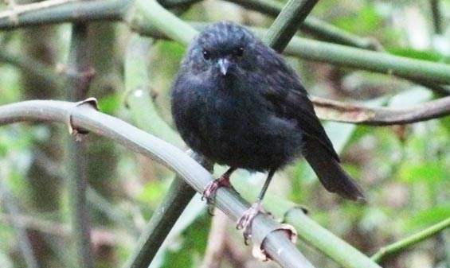
Run by DOC's Chatham Island Office, this volunteer programme is an integral part of the annual work plan for the island. Without it, critical work on the two off shore island nature reserves would not happen. The avifauna monitoring programmes require teams of highly skilled bird observers, handlers and banders for weeks at a time to complete the field work.
When working with species such as black robin, chatham petrel and forbes parakeet, there is no room for error, so volunteers must have the necessary skills and competence to carry out the work with minimum supervision.
Resource F: The Black Robin
By 1900, the introduction of rats and cats following human settlement had wiped out the birds from everywhere apart from Little Mangere Island. The accidental introduction of predators to the two islands where it presently survives is still a threat.
All black robins have the same weaknesses and strengths, stemming from the fact they have similar DNA. This means that a single disease could kill them.
Escape from extinction
In 1972 wildlife officers could find only 18 black robins living on Little Mangere Island. In 1976 there were only seven birds left. These were all moved to Mangere Island where 120,000 trees had been planted to provide better shelter. By 1980 a further two birds had died, and none had bred.
There were only five black robins in the world in 1980, with just a single breeding pair left. The outlook was bleak, but a dedicated team of New Zealand Wildlife Service staff took the daring step of cross-fostering eggs and young to another species to boost productivity.
The last breeding pair named Old Blue (female) and Old Yellow (male), and a foster species, the Chatham Island tits, ended up saving the black robin from extinction.
In early 2013, the black robin population was around 250. Numbers remain stable.
Attempts made to establish another population in a fenced convenant on Pitt Island have failed, possibly due to competition for food with introduced mice.
Model for success
The fostering programme used to save the black robin was such a fantastic success that it has been used as a case model on how to save endangered birds around the world.
With the black robin population now well-established on Mangere and South East Islands, we hope to establish further populations in predator-free areas on Pitt and Chatham Islands.
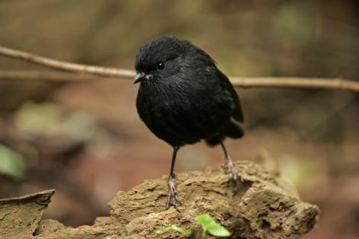
There are even hopes that the black robin may one day be returned to its ancestral home, Little Mangere, where the vegetation is slowly regenerating.
Resource G: Living in isolation on the Chatham Islands
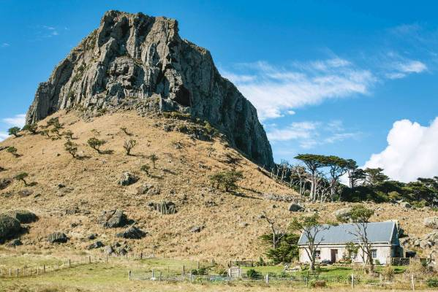
Helen Bint is content. She lives a pioneering lifestyle 1075 kilometres from Auckland, 50 kilometres from Waitangi – Waitangi, Chatham Islands, that is – and a final few kilometres across a paddock. She lives alone in a Category 1-listed historic stone cottage where she spent part of her childhood, in the shadow of a massive rocky outcrop almost 200 metres high.
There is no electricity and few home comforts. Her nearest neighbour, Nick Zimmerman, originally from Switzerland, lives 10 kilometres away on a farm that 100 years ago spread over 8000 hectares and was owned by Helen's grandparents.
For a long time Helen had yearned to go back to her pioneering roots, living like the old people had lived. After raising five children and spending years in horticultural pursuits as diverse as working on hop farms, picking raspberries and the occasional gardening job, she eventually found that food and general living costs were too expensive in the city. That and her husband's religious beliefs plus a mortgage weighing her down led to her making the life-changing decision to return to the Chathams. Her children had left home but encouraged her, saying, "Good on you, Mum – go off and have adventures".
It's been close on three years since Helen made the move. In that time she has been interested in investigating the history of the house and gathering information about her ancestors; she is keen to relate much of this to an increasing number of visitors.
She gestures at the hill behind the cottage, known as Maunganui, saying it is the remnant of a volcano and hopes "it won't do that again, at least not while I'm living here". This huge outcrop came in very useful when five German Moravian missionaries arrived in the 1840s. Two of them, Johann Engst and Johannes Baucke, settled down and between 1866 and 1868 built a house with blocks of basalt stone hewn from its rocky flanks, axe and saw their only tools.
The outpost they created became known as the Mission House.Although no converts were claimed, it's said that Engst held a service of the hellfire kind there every night. Later it became known as the Stone Cottage. It stands alone today, a prominent landmark on the Chathams. Early photos show outbuildings, long since vanished, and the remnants of a dying forest, but the house remains virtually unchanged.
It's a long drive from Waitangi over gravel roads and then across a paddock; with typical Island hospitality Helen warmly welcomes visitors. She is definitely on the tourist route and remarks, "I think I have been discovered. Just yesterday three young men off a yacht called in on their way to Chile".
The weather-worn timber front door opens directly onto a small room that doubles as a living room and kitchen. Two large sofas and three chairs occupy much of the floor space and the memorabilia of a long life is arranged on shelves and on the walls. A simple kitchen lines the far wall where a gas hob is one of the very few modern appliances. It's not possible to run a fridge or freezer and Helen says any meat or fish will last only three days.
A solar lantern provides light, sufficient for reading history books at night – she likes facts, not fiction, and enjoys NZ Life & Leisure. In one corner a portable radio, running off a battery charged by a small solar panel, belts out some of her favourite country music. An old-fashioned rack for drying clothes hangs from the ceiling. That's all she needs although she admits there's a brand-new generator sitting out the back that has never been turned on. There is no TV and certainly no cell phone but by some miracle of modern technology Helen communicates with the outside world by telephone and talks to her family in Nelson on a regular basis.
She is not fazed by the isolation. She doesn't miss anything except her family and friends. She goes to town in her four-wheel-drive Hilux, usually on a Tuesday, when she has lunch with her sister Shirley, collects the mail, the gas bottle, the groceries and the diesel. She thinks she is well off compared to her grandmother who got in groceries only once a year.
Loneliness is not a concern as Helen fills her time with cooking and gardening. Weka and possums are the bane of her life and her vegetable garden is well fenced to keep them out. These pests leave pumpkins and potatoes alone but it's an uphill battle. Nic Zimmerman gives her meat and apples so she doesn't have to buy much; milk comes from her goats, eggs from her chooks and mussels from rocks down at the beach. Walking on the beach is a daily pleasure when the weather is fine – it's just a few minutes over the sand-hill where endangered oyster catcher birds are often seen.
There are hundreds of things to do. An entertaining menagerie helps to keep her company. Jill the fox terrier is always by her side along with Wag, a retired pig dog of uncertain parentage. There's a black cat called Tiki and two tiny bundles of doggie fluff, Elmo and Honey, said to be Pekinese crossed with chihuahua . Outdoor free rangers include two goats, five roosters and 15 hens. Helen has a wry sense of humour. She says she never tires of the roosters crowing and it's as if the Beverly Hillbillies are here except she hasn't struck oil.
Helen Bint leads a contented life. She misses her friends but expects to stay for years. Besides, she has planted lots of trees and wants to see them grow tall. She goes to Nelson about three times a year to see her family but is tired of people asking if she is getting married again. The reply comes instantly. "No! I'd rather have a carrot cake. I could have a piece every night without the consequences."
The Chathams , population 600, are a group of 10 islands in the Pacific Ocean almost 700 kilometres south-east of mainland New Zealand and in a time zone 45 minutes ahead. The second-largest island, Pitt, just west of the international date line , is the first inhabited land in the world to see the new dawn. A ship from Timaru lands heavy freight weekly. The trip takes two days and the fare for a passenger is $300, the same as for a cow, a crew man jokes. Air Chathams flies daily to and from the mainland.
A small hand-painted sign by the Post Office makes known that the antipodes (a place diametrically opposite) of Waitangi, the island's main township, is Alzon in France. When Val Croon, a well-known local, was travelling around there he came upon Alzon and was astonished to see someone walking down the street wearing a Chatham Islands t-shirt.
Living costs are expensive but the Islanders are known to be resourceful. Helen Bint explains that because of the Islands' small population everyone feels as if they are first cousins. She says, "You know everyone and you take time to talk"; waving to passing cars is the normal thing. "The Islanders help one another and you don't need to be scared of burglars as everyone knows everyone else."
Resource H: The Moriori of the Chatham Islands
The Moriori people are included here with the first settlers because traditional and genealogical evidence points to their having left New Zealand before the arrival of the Fleet in 1350. If the Toi expedition of 1150 had arrived before they left, it is more than probable that it had no effect upon the culture of the emigrants. Hence the Moriori may be regarded as the pure descendants of the tangata whenua first settlers who from their isolation did not share in the legends, stories, and cultural changes introduced and developed in New Zealand after their departure.
The Chatham Islands lie 536 miles east of Port Lyttelton in latitude 43 degrees south. The first European visitor was Captain Broughton on the armed tender Chatham in 1790. He named the largest island, about 31 miles long, after his ship. The native name of the large island was Rekohu but the Maori invaders of 1835-36 gave it the name of Wharekauri which Shand (65, p. 152) pointed out was due to the following mistake. Two Maori named Ropata Tamaihengia and Pakiwhara visited the island on a whaling ship and Ropata stayed at a village named Wharekauri which name, owing to his misunderstanding of the Moriori dialect, he took to be that of the island. On their return to Wellington, Pakiwhara told the Ngati Mutunga and Ngati Tama tribes there about the rich supply of fish, shell fish, and preserved birds on the island of Wharekauri. Influenced by the rich food supplies, these tribes invaded the island and naturally called it Wharekauri. The Maori name replaced the original Moriori name of Rekohu but the change definitely took place after 1835.
The native flora included the braken fern (eruhe, Pterisaquilina), native flax (Phormium tenax), tree fern (mamaku, Cyathea medullaris), and karaka (Corynocarpus laevigata), all of which were present in New Zealand and used for the same purposes. The native trees were small, the largest being the karaka, the wood of which was unsuitable for making canoes. Owing to the absence of suitable timber, the people resorted to making rafts of the dry flower stalks (korari) of the native flax. The loss of the craft of canoe building was not due to degeneration but to the lack of suitable raw material.
The waters of a large lagoon and the surrounding sea provided a rich supply of fish. The shores yielded quantities of shell fish which included the paua (Haliotis sp.). The neighbouring islets were utilized as rookeries by the albatross (toroa) and other sea birds. The Moriori made risky voyages in their flax-stalk rafts to obtain young albatross in the breeding season, and these were preserved in their own fat.
The Moriori people were estimated by Broughton to number 1,600 at the time of his visit. The Maori invaders of 1835-36 killed a number and took many of their women as wives. Introduced diseases and intermarriage page 14reduced the number of full-blooded Moriori. Bishop Selwyn, in 1848, estimated their number at 268, and Skinner, in 1920, found that there were only two full-blooded Moriori living on the island. I later discovered a full-blooded male living at Dargaville in New Zealand. All three have since died and the Moriori became extinct as a separate people, but their blood is present in some mixed Maori families.

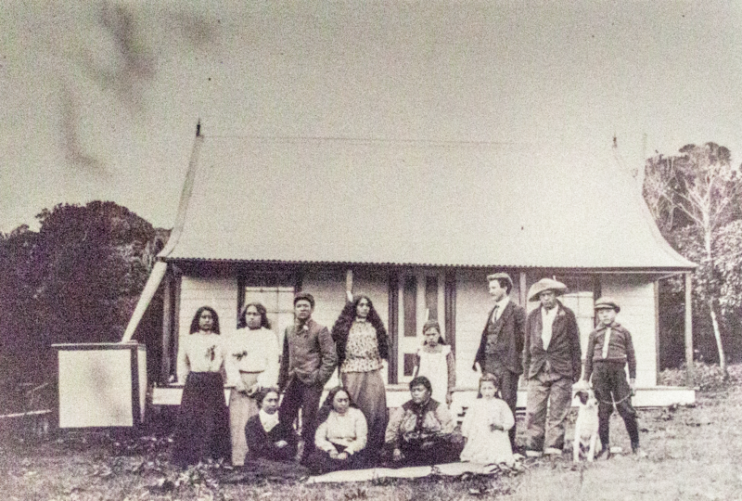
A group of Moriori and Māori people, from the late 19th century.

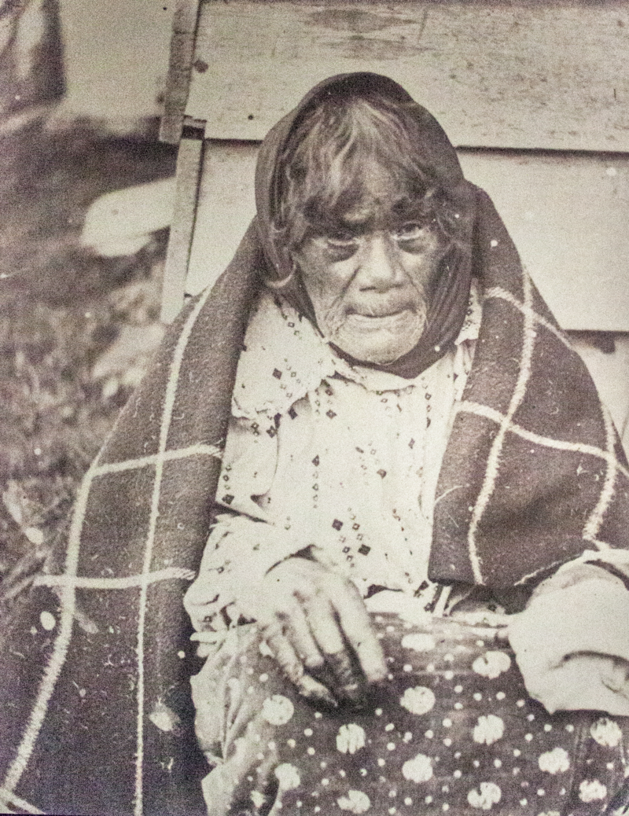

A late 19th-century photograph of a Moriori woman in Western clothing.
Resource I: Air Chathams History
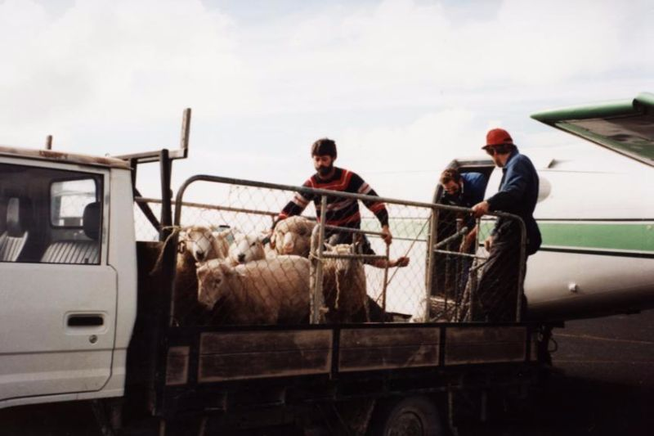
Owned by Craig and Marion Emeny, Air Chathams was established in 1984 and has worked with the local Chatham Island people to create a reliable and safe airline that would support the transportation of both freight and people to and from New Zealand.
Craig Emeny first moved to the Chatham Islands when he was offered employment through a NZ based airline that required a pilot to operate services primarily between Chatham and Pitt Islands. At that time there was no regular service between the Chathams and NZ, and it was this lack of service regularity that saw Craig start his own airline in 1984 and begin operations to mainland NZ airports. Since Air Chathams was based on the Chatham Islands they were able to avoid many of the weather related issues that plagued other airlines operating the sector from NZ. The freight market developed steadily, as well as offering an extra option for locals to visit friends and family in NZ. Air Chathams has thus grown from operating small piston engine aircraft to large 50 seat two engine turbo-prop aircraft, and played a major part in allowing the Chatham Islands fishing economy to compete globally.
Air Chathams have specialised in the transportation of perishable freight such as fish products destined to the overseas markets.
Additionally Air Chathams have worked extensively in the Charter field utilising the Convair 580 aircraft to carry sports teams, tour groups and others. The Convair has proven to be particularly popular for charter work as it has plenty of leg room and is well suited to carrying extra baggage and freight when required.
Air Chathams charters have seen it regularly flying over the skies of New Zealand, Australia and the South Pacific.
Resource J: Accessibility
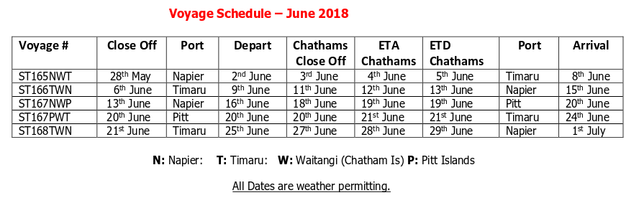
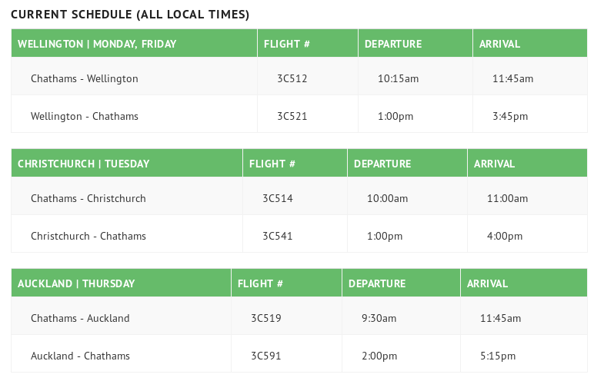
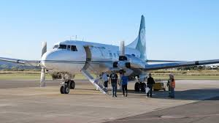
Resource K: Climate change projections for the Chatham Islands
This page provides an overview of how the climate in the Chatham Islands is likely to change in the future and what implications this has for the region.
Projections of climate change depend on future greenhouse gas emissions, which are uncertain. There are four main global emissions scenarios ranging from low to high greenhouse gas concentrations. This page presents regional projections as a range of values from a low emissions to a high emissions future.
The projected changes are calculated for 2031–2050 (referred to as 2040) and 2081–2100 (2090) compared to the climate of 1986–2005 (1995).

Temperature
Compared to 1995, temperatures are likely to be 0.7˚C to 1.0˚C warmer by 2040 and 0.7˚C to 2.8˚C warmer by 2090.
By 2090 the Chatham Islands are expected to experience fewer frosts, and more days per year where maximum temperatures exceed 25˚C.

Rainfall
The Chatham Islands are expected to become wetter, particularly in winter and spring. Winter rainfall is projected to increase by 5 to 11 per cent by 2090 and spring rainfall is expected to increase by 6 to 8 per cent for the same period.
Extreme rainy days may become more frequent in the region.

Wind
Changes in wind direction may lead to an increase in the frequency of westerly winds over the Chathams by 2090.

Sea-level rise
New Zealand tide records show an average rise in relative mean sea level of 1.7 mm per year over the 20th century. Globally, the rate of rise has increased and further rise is expected in the future.
The Ministry for the Environment provides guidance on coastal hazards and climate change, including recommendations for sea level rise.

Impacts by season

By 2090, the region could expect*:
Spring | - 0.7°C to 2.6°C temperature rise  - 6 to 8 per cent more rainfall
Summer | - 0.6°C to 2.8°C temperature rise  - 1 to 4 per cent more rainfall
Autumn | - 0.7°C to 3.0°C temperature rise  - 1 to 5 per cent more rainfall
Winter | - 0.7°C to 3.0°C temperature rise  - 5 to 11 per cent more rainfall
*Projected changes are relative to 1995 levels. The values provided capture the range across all scenarios. They are based on scenario estimates and should not be taken as definitive. For more information, see the full report on climate projections.

What could this mean for the Chatham Islands?
Flooding – More heavy rainfall will increase the risk of flooding on the islands. For instance, higher water levels in Te Whanga lagoon after heavy rainfall could increase the risk of surface flooding of nearby roads.
Coastal hazards – Coastal roads and infrastructure may face increased risk from coastal erosion and inundation, increased storminess and sea-level rise.
Biosecurity – Warmer, wetter conditions could increase the spread of pests and weeds.

Resource L: $52m wharf opens on Chatham Island
Chatham Islanders are hoping their new wharf will make life on the island much smoother sailing.
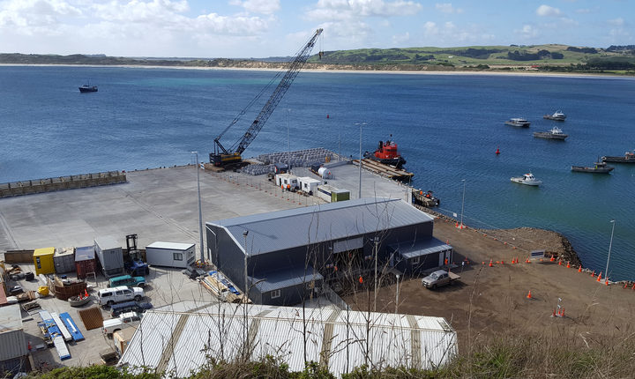
About a third of the 600 people who live on Chatham Island turned up as Internal Affairs Minister Tracey Martin officially opened the $52 million wharf yesterday.
Those behind the project hope it will reduce the number of days ships can't dock from 70 a year to 15.
Monique Croon runs the local hardware store and hopes the new wharf will make her business run more smoothly.
Her customers would get grumpy when the ships couldn't get in, she said.
"So you're running out of petrol, groceries - essential supplies, some would say beer is essential - when you run out of that, that's tough times.
"So having this all-weather port, this great facility and also a fisherman's wharf that is nice and clean for exporting our fish and our produce."
Before construction on the wharf and the 163m breakwater could begin, a quarry had to be established on the island to provide the rock and concrete for the project.
Memorial Park Alliance manager Hugh Milliken said the island's isolation made it one of the hardest projects he had ever done.
"The reason we got the breakwater is because there's not a lot of protection here from the predominant sou'wester. It's the same weather that comes across the Tasman and hits New Zealand ... so the weather here gets very large.
"It means when a ship comes in the ship can't tie up at any wharf structure so we had to build something out in front of it to protect it."
Ms Martin said the new wharf would have a big impact on the island.
"With the regard to the difference that it is going to make, I think it's that continuity, it lets the industry here grow."
Locals took the opportunity to hit up the government ministers on the trip up for other infrastructure too.
And they got a sympathetic ear from the Deputy Prime Minister Winston Peters.
"This is a seriously viable part of New Zealand's economy - they would have one of the highest if not the highest exports per person in the whole wide country of New Zealand.
"So they deserve to be looked after properly, because they pay their taxes and they raise huge export wealth for New Zealand," Mr Peters said.
The government was also spending about $12m upgrading the wharf on neighbouring Pitt Island, which has a population of 30 people.

SOURCES
- Resource A: openstreetmap, https://en.wikipedia.org/wiki/Chatham_Islands, https://en.wikipedia.org/wiki/Waitangi,_Chatham_Islands
- Resource B: LINZ
- Resource C: https://teara.govt.nz/en/chatham-islands , https://teara.govt.nz/en/map/8953/chatham-rise
- Resource D: Statistics New Zealand
- Resource E: https://www.doc.govt.nz/news/stories/2014/june/volunteering-on-the-chatham-islands/
- Resource F: http://www.nzbirdsonline.org.nz/species/black-robin (photo), https://www.doc.govt.nz/nature/native-animals/birds/birds-a-z/black-robin/
- Resource G: https://www.stuff.co.nz/life-style/nz-life-leisure/72077747/Living-in-isolation-on-the-Chatham-Islands
- Resource H: http://nzetc.victoria.ac.nz/tm/scholarly/tei-BucTheC-t1-g1-t1-body1-d3-d4.html ,https://www.atlasobscura.com/articles/moriori-people-genocide-history-chatham-islands
- Resource I: https://www.airchathams.co.nz/about-air-chathams/air-chathams/
- Resource J:https://www.airchathams.co.nz/Airline-Info/flight-schedule/, http://www.chathamislandsshipping.co.nz/images/Voyage_Schedule_-_June_2018.pdf
- Resource K: http://www.mfe.govt.nz/climate-change/how-climate-change-affects-nz/how-might-climate-change-affect-my-region/chatham
- Resource L: https://www.radionz.co.nz/news/national/352549/52m-wharf-opens-on-chatham-island

